### **Components of a Neo4j graph**

* Nodes
* Labels
* Relationships
* Properties

### **Data modeling process**

Here are the steps to create a graph data model:

1. Understand the domain and define specific use cases (questions) for the application.
2. Develop the initial graph data model:
   1. Model the nodes (entities).
   2. Model the relationships between nodes.
3. Test the use cases against the initial data model.
4. Create the graph (instance model) with test data using Cypher.
5. Test the use cases, including performance against the graph.
6. Refactor (improve) the graph data model due to a change in the key use cases or for performance reasons.
7. Implement the refactoring on the graph and retest using Cypher.

Graph data modeling is an iterative process. Your initial graph data model is a starting point, but as you learn more about the use cases or if the use cases change, the initial graph data model will need to change. In addition, you may find that especially when the graph scales, you will need to modify the graph (refactor) to achieve the best performance for your key use cases.

Refactoring is very common in the development process. A Neo4j graph has an optional schema which is quite flexible, unlike the schema in an RDBMS. A Cypher developer can easily modify the graph to represent an improved data model.

## **Understanding the domain for your application**

Before you begin the data modeling process you must:

* Identify the stakeholders and developers of the application.
* With the stakeholders and developers:
  + Describe the application in detail.
  + Identify the users of the application (people, systems).
  + Agree upon the use cases for the application.
  + Rank the importance of the use cases.

### **Data model**

The data model describes the labels, relationships, and properties for the graph. It does not have specific data that will be created in the graph.

Here is an example of a data model:

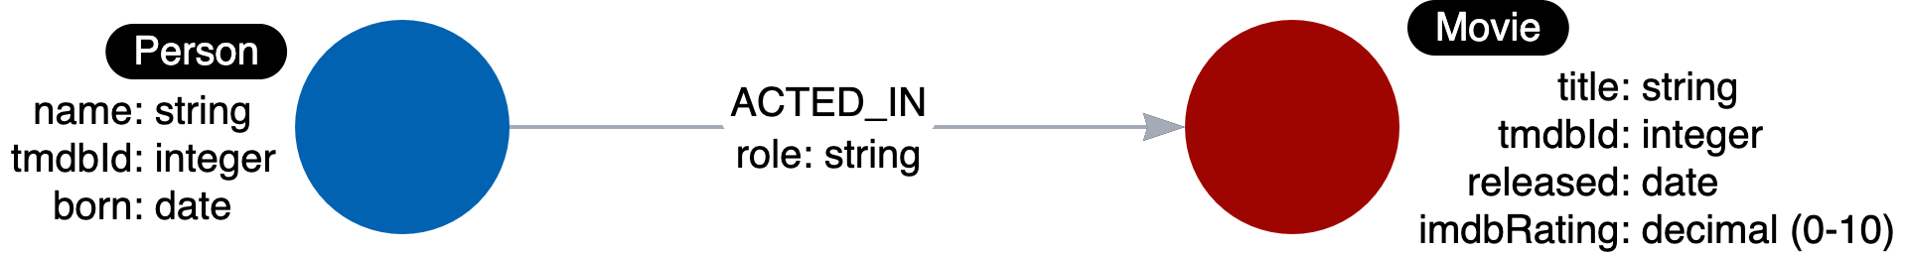

There is nothing that uniquely identifies a node with a given label. A graph data model, however, is important because it defines the names that will be used for labels, relationship types, and properties when the graph is created and used by the application.

### **Style guidelines for modeling**

As you begin the graph data modeling process, it is important that you agree upon how labels, relationship types, and property keys are named. Labels, relationship types, and property keys are case-sensitive, unlike Cypher keywords which are case-insensitive.

A Neo4j best practice is to use the following when you name the elements of the graph, but you are free to use any convention for your application.

* A label is a single identifier that begins with a capital letter and can be [CamelCase](https://en.wikipedia.org/wiki/Camel_case).
  + Examples: Person, Company, GitHubRepo
* A relationship type is a single identifier that is in all capital letters with the underscore character.
  + Examples: FOLLOWS, MARRIED_TO
* A property key for a node or a relationship is a single identifier that begins with a lower-case letter and can be [camelCase](https://en.wikipedia.org/wiki/Camel_case).
  + Examples: deptId, firstName

Note: Property key names need not be unique. For example, a *Person* node and a *Movie* node, each can have the property key of *tmdbId*.

### **Instance model**

An important part of the graph data modeling process is to test the model against the use cases. To do this, you need to have a set of sample data that you can use to see if the use cases can be answered with the model.

Here is an example of an instance model:

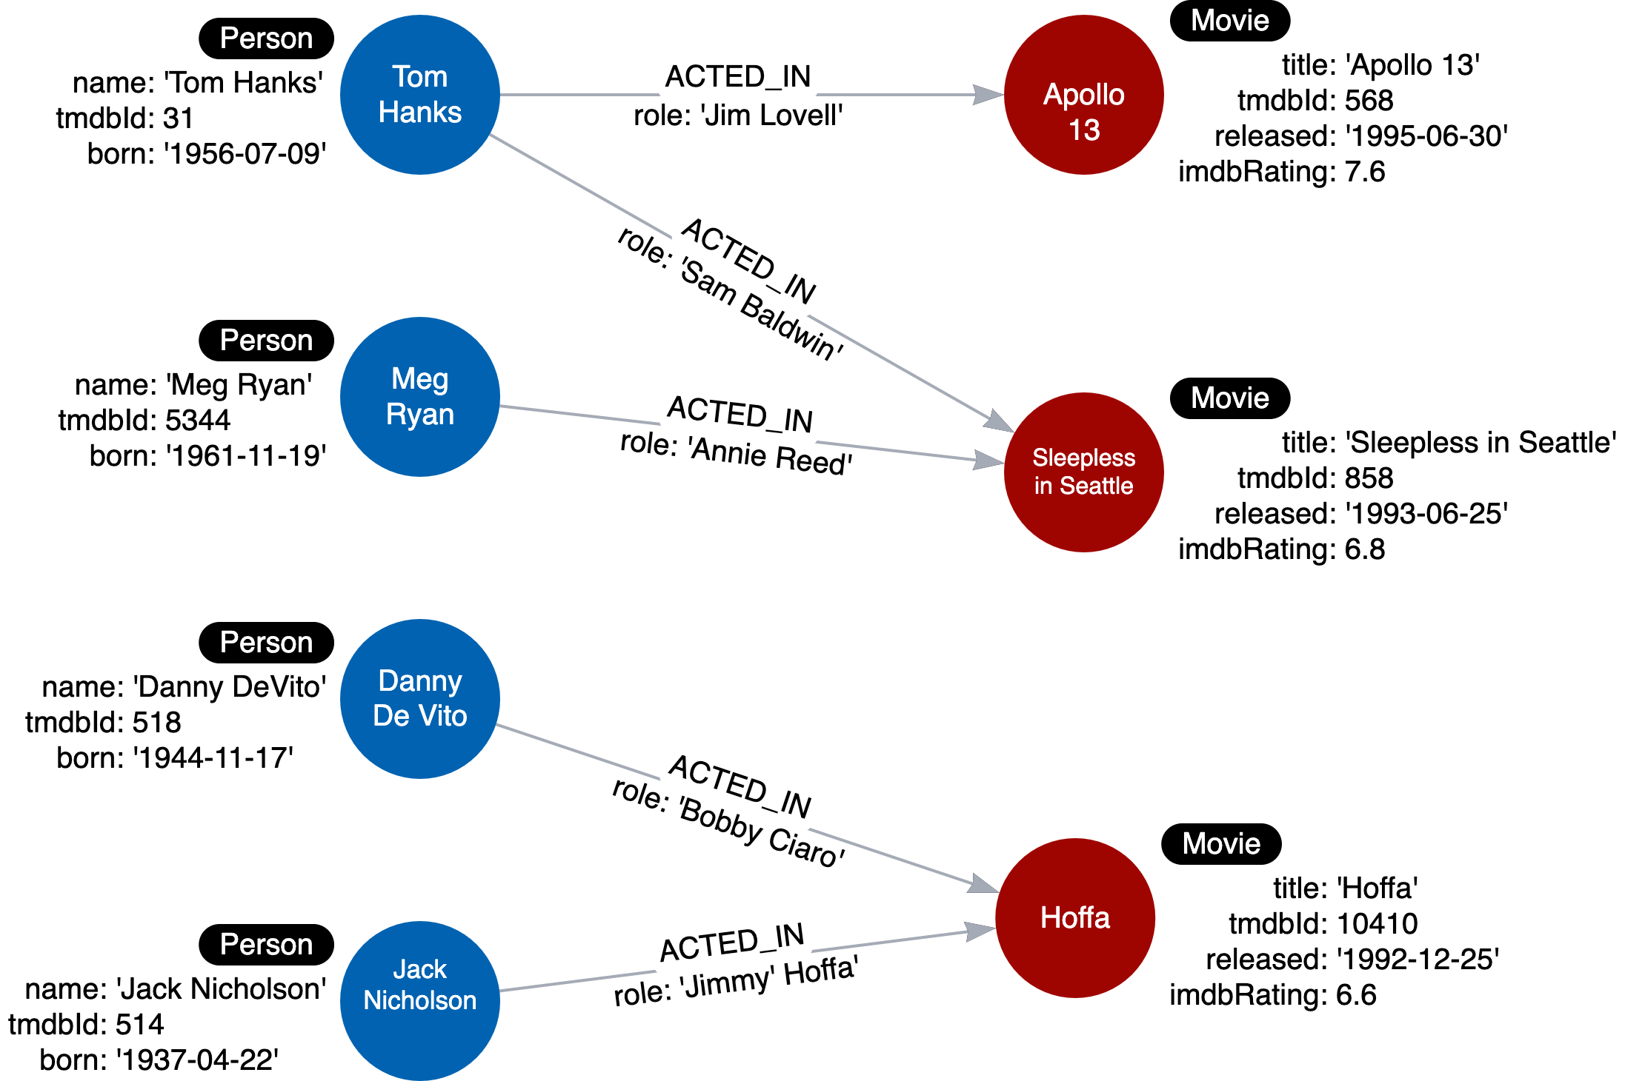

In this instance model, we have created some instances of Person and Movie nodes, as well as their relationships. Having this type of instance model will help us to test our use cases.